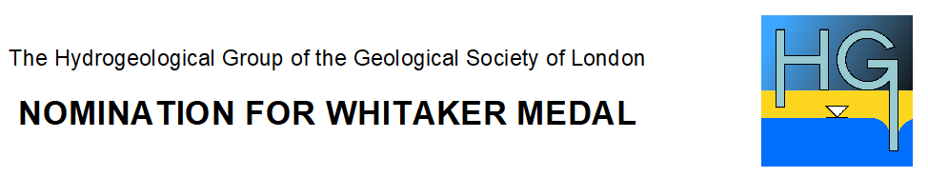Strictly Confidential FORM HG1

Please read the guidance notes before submitting the form. All information must be provided on this form. Attachments will not be considered.

Name of nominee in full: | Fellow/Non-Fellow (if known):
Institution:

Address:

Tel:
E-mail:

The Whitaker Medal is awarded in recognition of an outstanding long-term contribution to hydrogeology.

Please state below how your nominee meets the criteria (no more than 500 words):

The form must be signed by the proposer and the seconder who must not be from the same institution as the nominee. Proposer and seconder should also be from different institutions to each other.

Proposed by: Signature:

Institution: Date:

Seconded by: Signature:

Institution: Date:

Please send completed form to: info@hydrogroup.org.uk

Please title your email ‘Medal Nomination’

